**Итоговый тест по английскому языку за курс 2 класса.**

**1.Подпиши названия животных на английском языке.**

[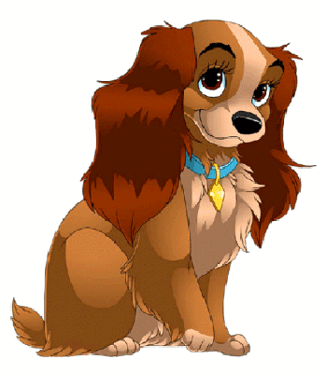](http://foto-zverey.ru/2/foto-zhivotnyh1.gif) [](http://allforchildren.ru/pictures/showimg/fish/fish008gif.htm) [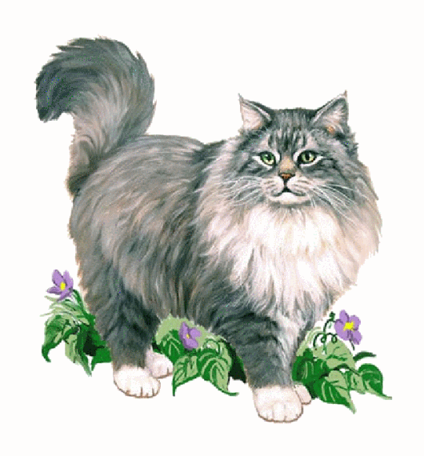](http://foto-zverey.ru/koshki/kisa27.gif) [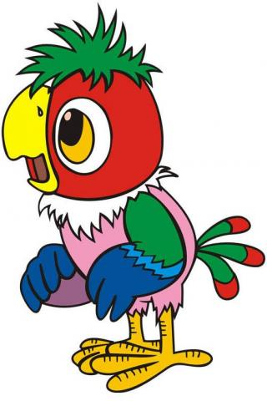](http://images.yandex.ru/yandsearch?source=wiz&fp=0&uinfo=ww-1349-wh-673-fw-1124-fh-467-pd-1&text=%D0%BA%D0%B0%D1%80%D1%82%D0%B8%D0%BD%D0%BA%D0%B8%20%D0%BF%D0%BE%D0%BF%D1%83%D0%B3%D0%B0%D1%8F%20%D0%BA%D0%B5%D1%88%D0%B8&noreask=1&pos=6&lr=47&rpt=simage&img_url=http://img0.liveinternet.ru/images/attach/c/3/77/864/77864324_8.png)

**2. Прочитай отрывок из письма Ани ее английскому другу Джону. О каком питомце Аня говорит? Найди правильный ответ и обведи букву.**

I have got a friend. It is red, blue and green. It is not sad. It is nice. It can swim well. It can`t fly and run. It`s name is Polly. It is one. It lives with me, my mum and dad. It likes my home. We like Polly too.

a) It is a cat. b) It is a cock c) It is a fish.

**3. Запиши данные слова в алфавитном порядке:**

dance, kangaroo, chimp, orange, grandma, ballerina, under, apple, sandwich, mouse.

_____________________________________________________________________

_____________________________________________________________________

**4. Поставь слова в правильном порядке, чтобы получились предложения. Запиши полученные предложения.**

1. like, don't, I, sandwiches. - _____________________________________________

2. eight, I'm.- __________________________________________________________

3. got, I've, eyes, green. - _________________________________________________

4. can, he, swim. - _____________________________________________________.

5. name, is, my, Jim. - ___________________________________________________.

**5. Подчеркни лишнее слово в каждой строке:**

1. a table, a chair, a chimp, a lamp, a bath.

2. two, three, four, five, he.

3. a horse, a kangaroo, a mouse, a ballerina, a snake.

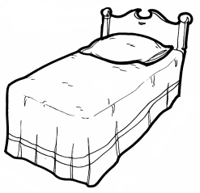**6. Прочитай и раскрась цветными карандашами:**

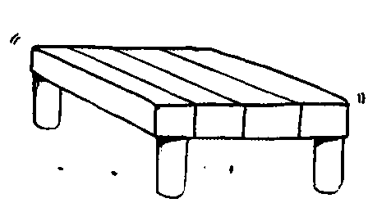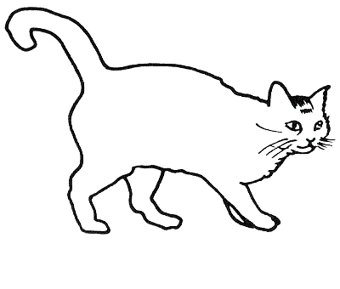

a yellow bed

a red toy soldier

a brown dog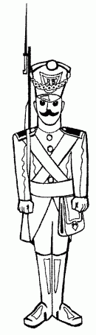

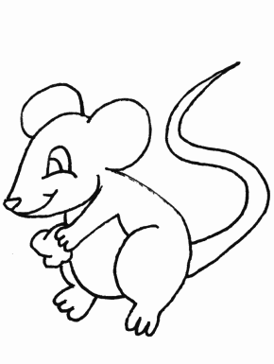a white mouse

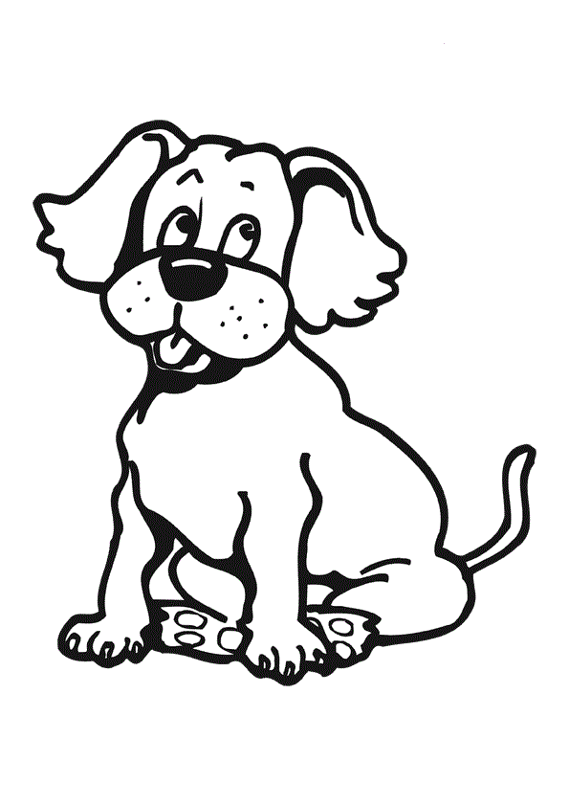a grey and black cat

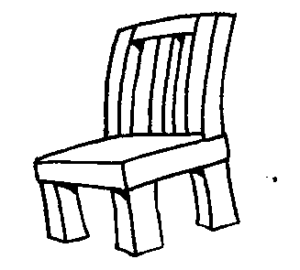a green table

a pink chair

**7. Выбери ответ и обведи нужную букву.**

1) Bob … got a clever dog.

a) have b) has

2) We … got ten tables.

a) have b) has

3) I … a boy.

a) am b) is c) are

4) My brothers … happy and funny.

a) am b) is c) are

5) … she sad?

a) am b) is c) are